Technical Architecture:

Project Design Phase-II Technology Stack (Architecture & Stack)

|  |  |
| --- | --- |
| Date | 03 October 2022 |
| Team ID | PNT2022TMID26285 |
| Project Name | AI-based localisation and classification of skin with Erythema |
| Maximum Marks | 4 Marks |

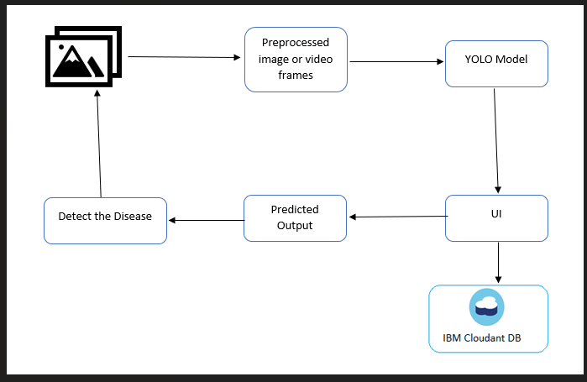

Table-1 : Components & Technologies:

|  |  |  |  |
| --- | --- | --- | --- |
| **S.No** | **Component** | **Description** | **Technology** |
| 1. | User Interface | The user interacts through the Web UI created | HTML, CSS, Python |
| 2. | Application Logic-1 | This is the works environment where we implement the methodology and execute the model | Pycharm/Spyder IDE |
| 3. | Application Logic-2 | It is the Microsoft Visual Object Tagging Tool used  to create an image dataset | VoTT |
| 4. | Application Logic-3 | It is the structure of the project used to build our  model | YOLO Structure |
| 5. | Cloud Database | Database Service on Cloud | IBM Cloudant |
| 6. | File Storage | File storage requirements | IBM Block Storage |
| 7. | Machine Learning Model | The purpose of our model is to localize erythema  skin disease and classify its type | Image classification model |
| 8. | Infrastructure (Cloud) | Application Deployment on Cloud | Cloud Foundary |

Table-2: Application Characteristics:

|  |  |  |  |
| --- | --- | --- | --- |
| **S.No** | **Characteristics** | **Description** | **Technology** |
| 1. | Open-Source Frameworks | Anaconda,Spyder/Pycharm,VoTT,YOLO | Programming |
| 2. | Security Implementations | Implementation of Firewalls | AI Firewall |
| 3. | Scalable Architecture | Scalability of architecture is Microservices | Cloud |
| 4. | Availability | Availability of application is based on cloud  allocation | Cloud |
| 5. | Performance | Design consideration for the performance of the application:   * number of requests is based on the server strength * Cache memory of the local server is used to store data | System memory |